**Real-Time Chat Application using Node.js and Socket.IO**

**A Project Based Learning Report Submitted To**

**for the degree of 2nd  year B.Tech**

**in**

**DEPARTMENT OF COMPUTER SCIENCE AND ENGINEERING (Data Science)**

**By**

Mr.Manish kumar yadav

**Under the Guidance of**

**Mr. Shekhar jalne**



**Kolhapur Institute of Technology’s**

**College of Engineering (Autonomous), Kolhapur**

**Year 2022-2023**

**Certificate**

This is to certify that following **S. Y. B.Tech (CSE)** students from KIT’s College of Engineering ,Kolhapur have completed Mini project successfully in partial fulfilment for the award of degree of B.Tech.(C.S.E).They worked on "....."project during **SEM-III, 2022-2023**  under the supervision of **Mr. Nikhil. Bhosale.**

Place: KIT Kolhapur

Date: //

**Mrs. Nikhil. Bhosale Dr. Uma Gurav Dr. V. V. Karjinni**

**Guide HOD CSE (AIML & DS) Director**

**Acknowledgement**

We are highly grateful to Dr. Uma Gurav, HOD CSE (AIML&DS), KIT’s College of Engineering, Kolhapur, for providing this opportunity to carry out the Project at CSE department. We would like to expresses our gratitude to other faculty members of CSE department for providing academic inputs, guidance & encouragement throughout this period. We would like to express a deep sense of gratitude.

Finally, we express my indebtedness to all who have directly or indirectly contributed to the successful completion of our project.

**ABSTRACT**The Real-Time Chat Application utilizing Node.js and Socket.IO revolutionizes instant messaging by delivering low-latency, bidirectional communication. Addressing traditional chat challenges, this project integrates a secure Node.js server and a dynamic client-side interface, fostering seamless real-time interactions. Users experience swift message handling through Socket.IO, ensuring instantaneous updates and responsiveness. The application's modular design allows for easy customization, making it an open-source, adaptable solution for diverse communication needs. Emphasizing simplicity, efficiency, and scalability, this project establishes a foundation for further innovation in the realm of real-time chat applications.

TABLE OF CONTENTS

**Sr No. Title Page No**

1 Introduction 1

2 Problem Statement 2

3 Objective

4 Requirements of this Project

5 DESIGN FLOW/PROCESS

6 Evolution of work

7 Planof work

8 Free To Use

9 Block Diagram

10 Live Image Capture

11 Conclusion

12 Future work

**1.Introduction:-**

In the digital era, real-time communication has become a fundamental aspect of online interactions. The Real-Time Chat Application using Node.js and Socket.IO aims to provide users with an instant messaging platform, allowing seamless communication in a dynamic and interactive manner.

**2. Problem Statement**

Traditional chat applications often face latency issues and lack real-time updates. The need for a robust and scalable solution that enables instantaneous communication is evident. This project addresses these challenges and aims to create an efficient real-time chat application.

**3. Objective**

The primary objective of this project is to develop a real-time chat application using Node.js and Socket.IO that offers low-latency communication, supports multiple users, and provides a user-friendly interface.

**4. Requirements of this Project**

* Node.js and npm installed
* Socket.IO library
* HTML, CSS, and JavaScript for client-side development
* Responsive design for cross-device compatibility

**5. DESIGN FLOW/PROCESS**

1. **Server Setup**: Initialize a Node.js server using Express and integrate Socket.IO for handling real-time communication.
2. **User Authentication**: Implement a simple authentication system to secure the chat application.
3. **Client-Side Interface**: Develop a user-friendly interface using HTML, CSS, and JavaScript for seamless interaction.
4. **Real-Time Communication**: Utilize Socket.IO to enable real-time bidirectional event-based communication between the server and clients.
5. **Message Handling**: Implement logic for sending, receiving, and displaying messages in the chat.

**6. Evolution of Work**

* **Milestone 1**: Basic server setup and user authentication.
* **Milestone 2**: Development of the client-side interface.
* **Milestone 3**: Integration of real-time communication with Socket.IO.
* **Milestone 4**: Message handling and display functionality.

**7. Plan of Work**

Hours 2: Server setup and user authentication.

Hours 3: Client-side interface development.

Hours 3: Integration of real-time communication.

Hours 3: Message handling and display logic.

**8. Free To Use**

This real-time chat application is open-source and free to use, allowing developers to customize and adapt it to their specific needs.

**9. Diagram**

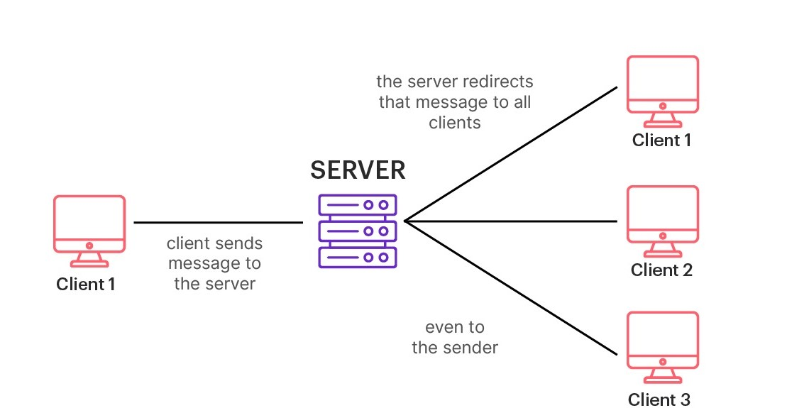

**10. Live Image Capture**

Include screenshots or live images demonstrating the real-time chat application in action.

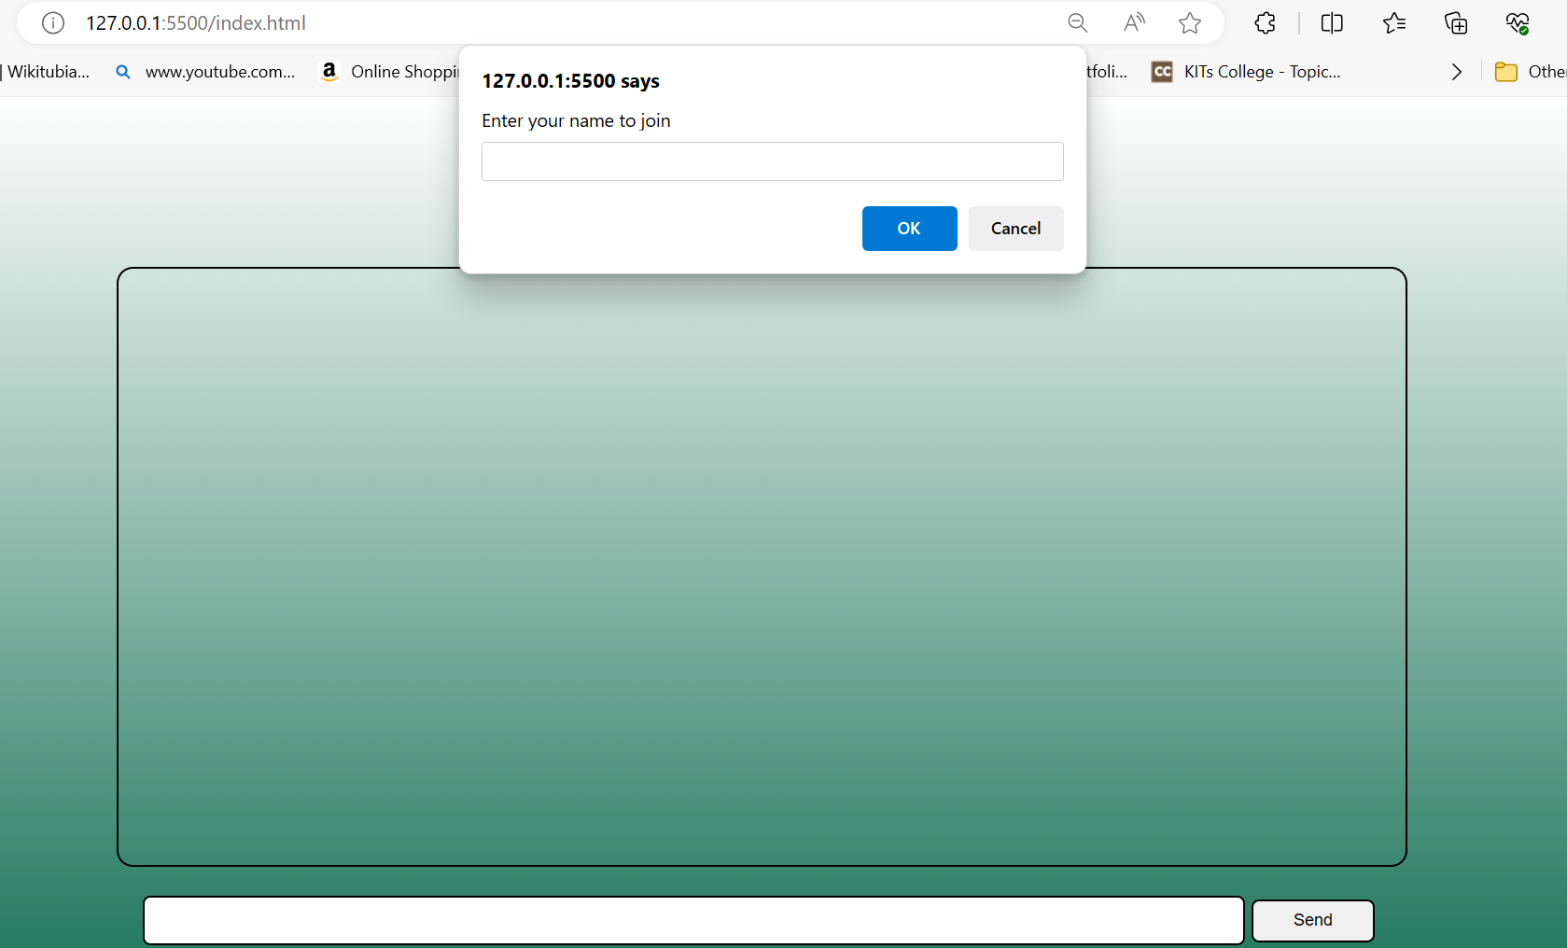

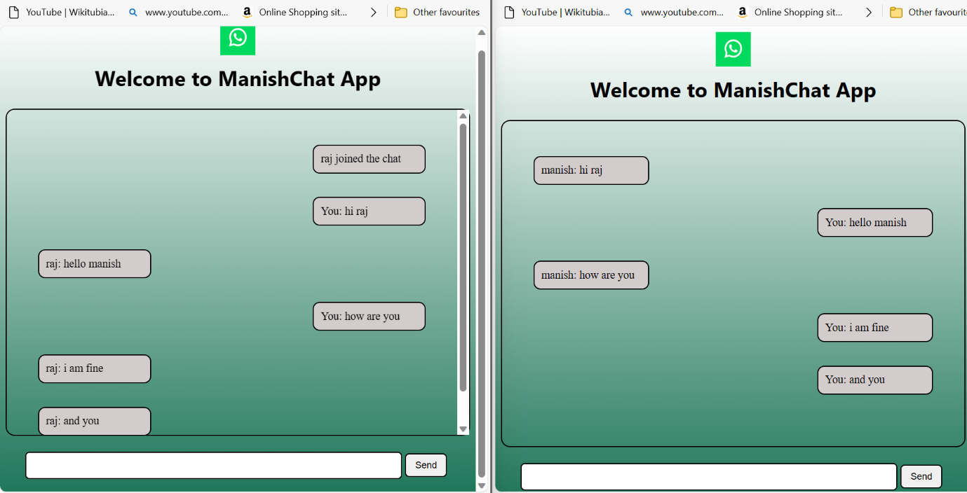

**11. Conclusion**

In conclusion, the Real-Time Chat Application using Node.js and Socket.IO offers a scalable and efficient solution for instant messaging, providing a foundation for further customization and development.

**12. Future Work**

Future enhancements may include:

* File sharing capabilities
* Group chat functionality
* Improved user interface and experience
* Integration with additional authentication providers

This project serves as a starting point for creating feature-rich real-time communication applications.